



Summer School 2020

Coding Boot Camp

Exercises 1

1. Swap the values of two variables.  
     
   name_1 = "Bob"

name_2 = "Alice"

# To show the value of variables, or literals, we use print statements.

print(name_1)

print(name_2)

1. Write a program to print the words of the counting song *Went To Mow A Meadow* using this flowchart as a guide.  
     
   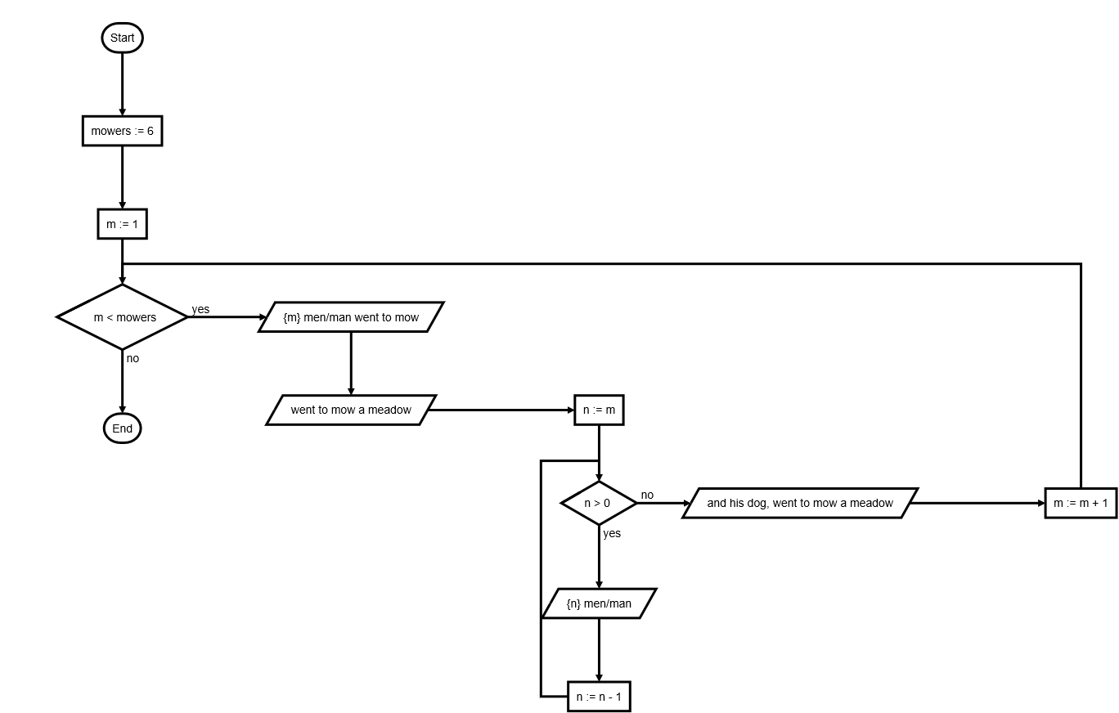

Revision 0.2 M Saunby 21/06/2020